

CHILD PROTECTION POLICY

Ballymena Area Children’s Contact Service believes that all children have the right to be protected at all times and that the welfare of the child is paramount. It recognises that child abuse occurs in all religions, all cultures and all social classes.
Confidentiality issues will be overridden by the need to act for the welfare of the child.
All children have the right to be safe and not to be hurt.

Introduction

Ballymena Area Children’s Contact Service aims to ensure that children remain safe and happy while at the Centre. Part of achieving this goal is the provision by the Management Committee of a Child Protection Policy, which users and referrers are made aware of and can see upon request. The Staff have been trained in the policy and procedure, and must themselves provide the names of two referees. All volunteers are vetted in accordance with the requirements of Access NI to ensure their suitability to work with children and young people.

Aim
The aim of the following Child Protection Policy is to provide guidance to the paid and volunteer staff of the Contact Centre, regarding how to respond to issues of child abuse.

Child Protection Principles

- All children have a right to be protected at all times.

- Where there is an allegation of child abuse, the interest and safety of the child must always come first.

- Considerations of confidentiality should not be allowed to override the right of the child to be protected from harm.

- Children have a right to be heard, to be listened to and to be taken seriously.

- Actions taken to protect a child should not in themselves be abusive by causing the child unnecessary distress or adding to any damage already suffered.

Types of Abuse

- Physical Abuse is the deliberate physical injury to a child, or the wilful or neglectful failure to prevent physical injury or suffering. This may include hitting, shaking, throwing, poisoning, burning or scalding, drowning, suffocating, confinement to a room or cot, or inappropriately giving drugs to control behaviour.

- Emotional Abuse is the persistent emotional ill-treatment of a child such as to cause severe and persistent adverse effects on the child’s emotional development. It may involve conveying to children that they are worthless or unloved, inadequate, or valued only insofar as they met the needs of another person. It may involve causing children frequently to feel frightened or in danger, or the exploitation or corruption of children. Some level of emotional abuse is involved in all types of ill-treatment of a child, though it may occur alone. Domestic violence, adult mental health problems and parental substance misuse may expose children to emotional abuse.

- Sexual Abuse involves forcing or enticing a child to take part in sexual activities. The activities may involve physical contact, including penetrative or non-penetrative acts. They may include non-contact activities, such as involving children looking at, or in the production of, pornographic material or watching sexual activities, or encouraging children to behave in sexually inappropriate ways.

- Neglect is the persistent failure to meet a child’s emotional and/or psychological needs, likely to result in significant harm. It may involve a parent or carer failing to provide adequate food, shelter and clothing, failing to protect a child from physical harm or danger, failing to ensure access to appropriate medical care or treatment, lack of stimulation or lack of supervision. It may also include non-organic failure to thrive (faltering growth).

Reference DHSSPS (2003) Cooperating to Safeguard Children

Procedure and guidelines for volunteers and staff to follow:

See flowchart overleaf

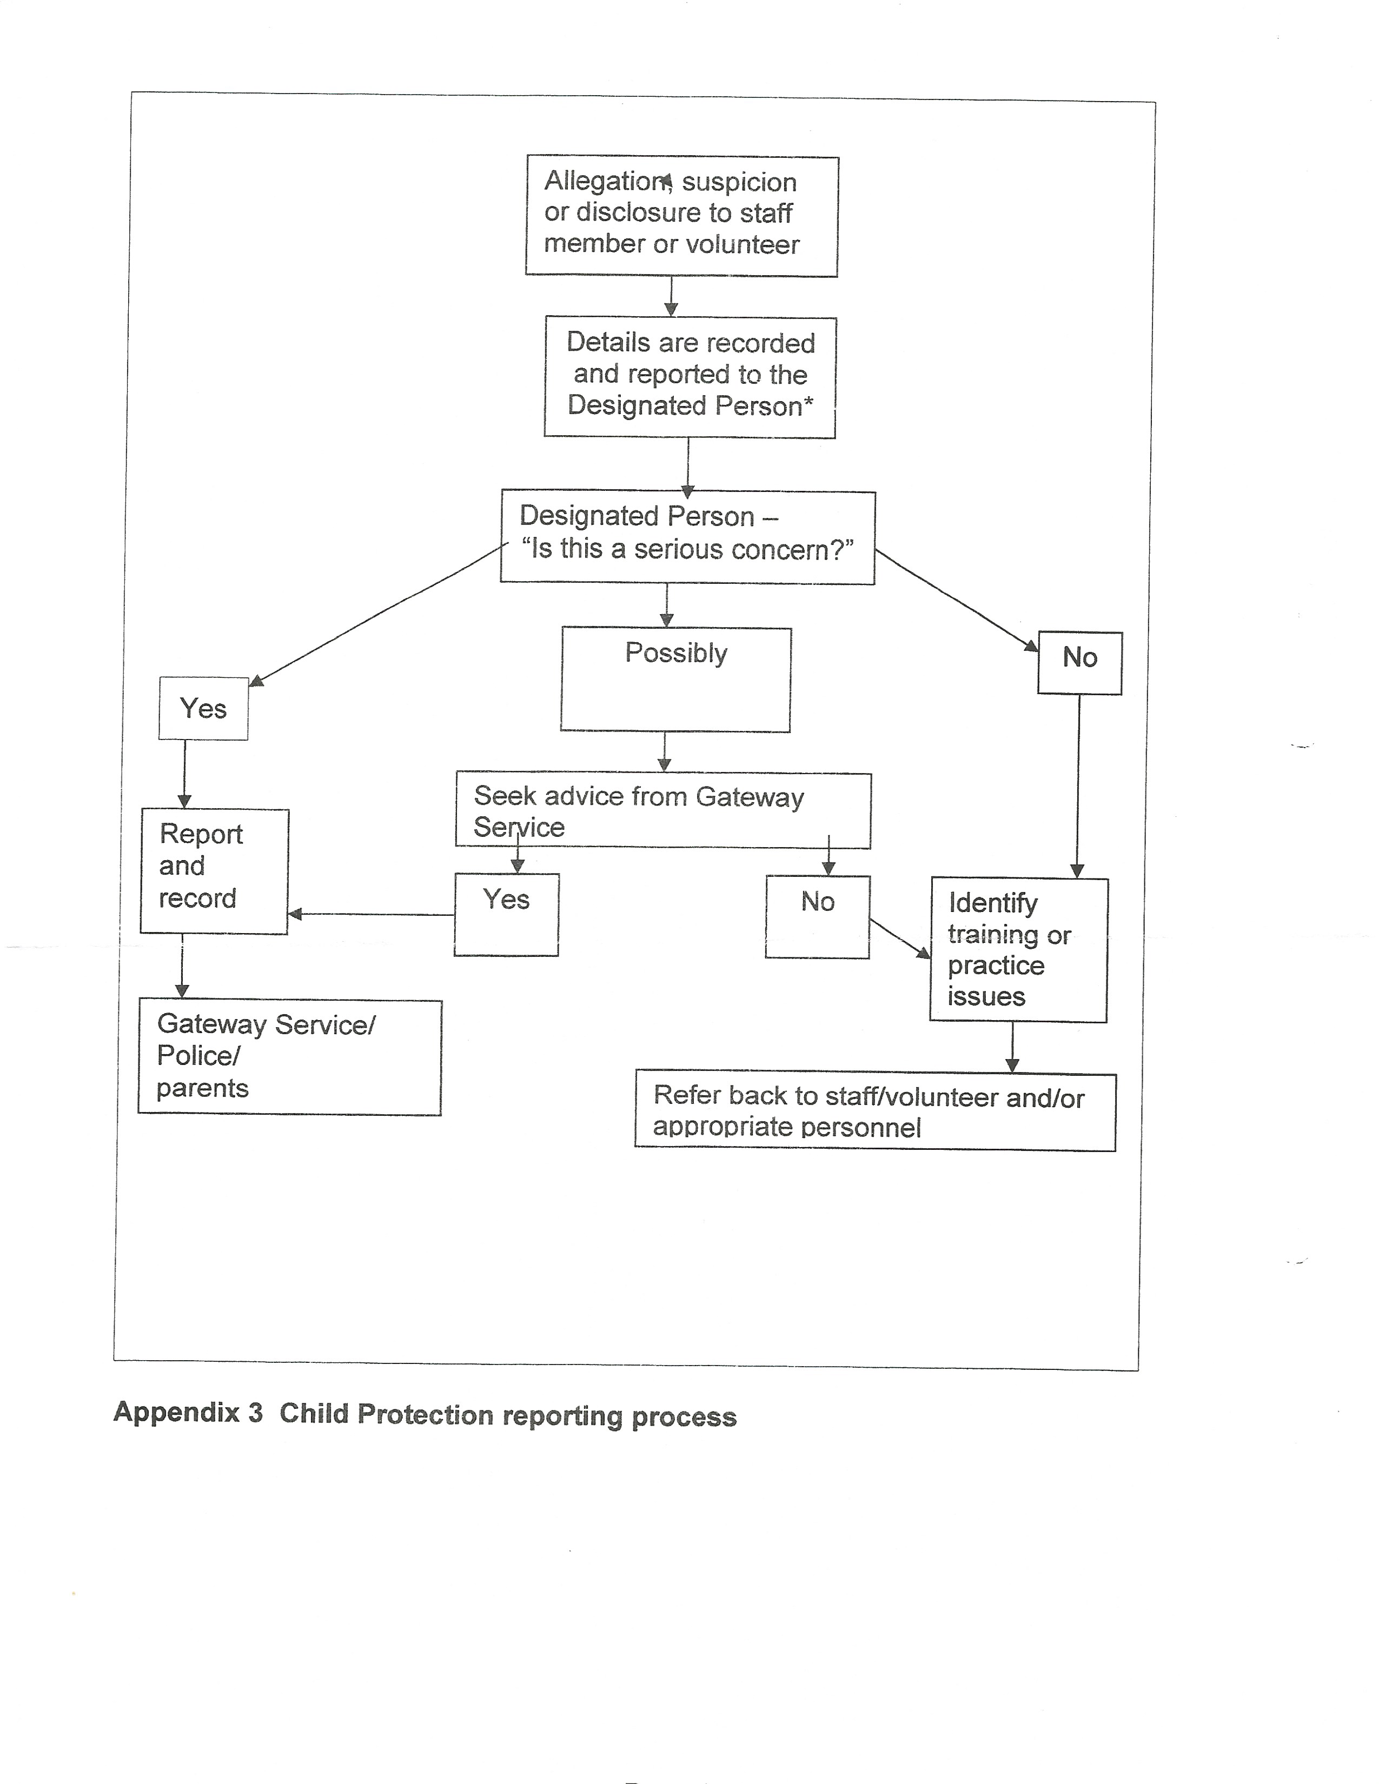

If a volunteer witnesses an incident of child abuse in the Centre, he/she should:

- Take whatever steps are necessary to ensure the safety of the child involved.

- Involve another volunteer and/or coordinator at the earliest opportunity.

- Report the incident to the coordinator who will record it.

If a child makes an allegation of abuse to a volunteer, the volunteer should:

- Take seriously what the child has said

- Report the allegation immediately to the coordinator who will record it.

If another adult makes an allegation of abuse to a volunteer, the volunteer should:

- Report the allegation immediately to the coordinator who will record it.

On receiving an allegation of or witnessing an incident of child abuse it is vitally important that the Coordinator be informed at the earliest possible time. Volunteers should not attempt to deal with it themselves. This is vitally important in order to ensure that the volunteer is not involved in any subsequent police /social services investigations, and more importantly to reduce the need for them to be

CALLED TO COURT

On receiving an allegation or witnessing an incident of child abuse, the coordinator, deputy coordinator, or whoever is in charge on the day shall, if deemed necessary, report the matter to:
- Social Services / Police
- Follow the advice given by the appropriate agency above
- Complete reports for the records

What to do when child abuse has been alleged or disclosed:

DO
- Stay calm
- Listen and hear
- Give the child/young person time to say what they want
- Reassure them that they have done the right thing in telling you
- Report to the coordinator
- Record the allegations

DON’T
- Do not panic. Try to act normally
- Don’t make the child repeat the story unnecessarily
- Don’t promise confidentiality – this is not possible if criminal acts are reported
- Don’t ask for details of the alleged abuse
- Don’t investigate – don’t ask leading questions
- Don’t attempt to deal with the problem alone
- Don’t challenge parents/carers about your concerns

