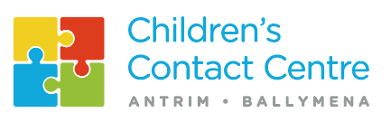

Privacy Notice

Here at Ballymena Area Children’s Contact Centre we take your privacy seriously. We will only use your personal data to help manage the contact. The personal details we receive from courts solicitors, social services, or indeed yourself, is securely stored under lock and key at our office in Broughshane. The data can only be accessed by our staff and will not be shared with any other agency, group, or individual, without your permission. No details that can identify you as an individual will leave the office.
When Contact finishes, all information is destroyed, by either shredding or burning.
Personal information held on computers will be deleted.
Information is only retained if required under the Data Protection Act.

I agree to my personal details and my children’s personal details, being held

Signed_________________________

